The 24th CIRP Conference on Life Cycle Engineering

The Evolution of Manufacturing Ecosystem in Cloud Manufacturing Architecture

Shengkai Chena , Shuiliang Fanga,b,∗

aKey Laboratory of Advanced Manufacturing Technology of Zhejiang Province, College of Mechanical Engineering, Zhejiang University, Hangzhou , 310027,

China

bThe State Key Laboratory of Fluid Power Transmission and Control, College of Mechanical Engineering, Zhejiang University, Hangzhou, 310027, China

* Corresponding author. Tel.: +86-135-8880-3980; *E-mail address:* me_fangsl@zju.edu.cn

Abstract

In cloud manufacturing, individuals engage in manufacturing business through the well-designed platform, where provider provide manufacturing resource for demander to search and purchase it. This business model allows platform operator to manage distributed massive manufacturing resources, which may help provider reduce the idle rate of their resources. However, in such manufacturing ecosystem, the heterogeneity attribute of resource makes it tough to classify them, and the chaotic operation mode makes it hard to meet demander's need. Cloud manufacturing ecosystem has more complicated relationship among individuals in it than that in normal manufacturing system, one individual can make decisions depend on the surroundings and others' with the help of integrated advanced technologies. Thus, in this paper, we designed an original operation mode with 3 extensions for the cloud manufacturing ecosystem to help describe some decision makings in individuals and the platform operator. With the help of Repast Simphony,

© 2017 The Authors. Published by Elsevier B.V.

Peer-review under responsibility of the scientific committee of the 24th CIRP Conference on Life Cycle Engineering.

*Keywords:* Cloud manufacturing ecosystem; Resource servitization and optimization; Operation mode; Manufacturing evolution; Agent-based simulation

1. Introduction

The relationship among individuals in cloud manufacturing system become more complicated than that in normal manufacturing system, since the integrated advanced technologies makes it possible to let one individual make decisions depend on the surroundings and others'. Demander prefer high quality performance while provider prefer high use rate of their resource, the cloud platform operator prefer lower amount of registered resource when dealing with almost arriving needs for an easier maintenance. These preferences stimulate the emergence of good service pattern that will lead to the evolution of manufacturing pattern in the cloud manufacturing ecosystem. Hence, it's important to identify good operation mode that help the evolution.

In this paper, we designed an original operation mode to describe the basic decision makings in cloud manufacturing ecosystem, then we proposed 3 extensions named metabolism mode, incubation mode and outsourcing mode. Finally, we deigned an experiment to validate these synthetic operation modes in an agent-based simulation method.

1. Review on cloud manufacturing and simulation

In cloud manufacturing context, platform operator can manage manufacturing service that encapsulated with distributed manufacturing resources intensively with appropriate business model[1], modular approaches and multi-layer architectures are the most common approaches to build the cloud manufacturing platform or system framework[2,3], Lv use list of views to depict this multi-layer architecture[4].

Servitization is the key philosophy to operate cloud manufacturing[5], service can be created statically which come along with provider[2] or can be created dynamically according to task pattern, such method as ‘Multi-Composition for Each Task’[6] that combines incompetent service into a whole, service can also be created by AI planning-based automatic composition framework[7].

Simulation approach have been widely used in manufacturing system on operations planning and scheduling, real-time control, operating polities, performance analysis[8]. In operating policies field, scheduling policies can be tested with simulation performance under given machine conditions[9], machine segmentation policies can be simulated in a combined MRP and Kanban production system[10]. Mourtzis et al.[11] explored a series of simulation-based solutions in industrial practice and considered that research trends are Internet and cloud based situation.

1. Design of the ecosystem
   1. Preliminaries

Before the design of the ecosystem, we specify some basic concepts:

* Provider: the individual who provide resource;
* Resource: the basic task process object with renewable capacity and unique type;
* Demander: the individual who publish order that contain bunch of tasks;
* Order: the task bundle like a project;
* Task: the basic object need to be processed with certain type and capacity of resource;
* Task-part: virtual segmentation unit of one task;
* Product: the perform result of task;
* Platform: the place where individual interact with other and environment.

With the cloud manufacturing platform operating, demander publish order while provider provide resource, then they make decisions to arrange the resources to perform tasks that decomposed from order. Most recent researchers like Wu et al.[12] describe this operation procedure in cloud manufacturing as a tri-group user model that contains: 1) users/customers, 2) application providers and 3) physical resource providers. Inspired by this model, we design the original operation mode shown in Fig. 1 as the basis.

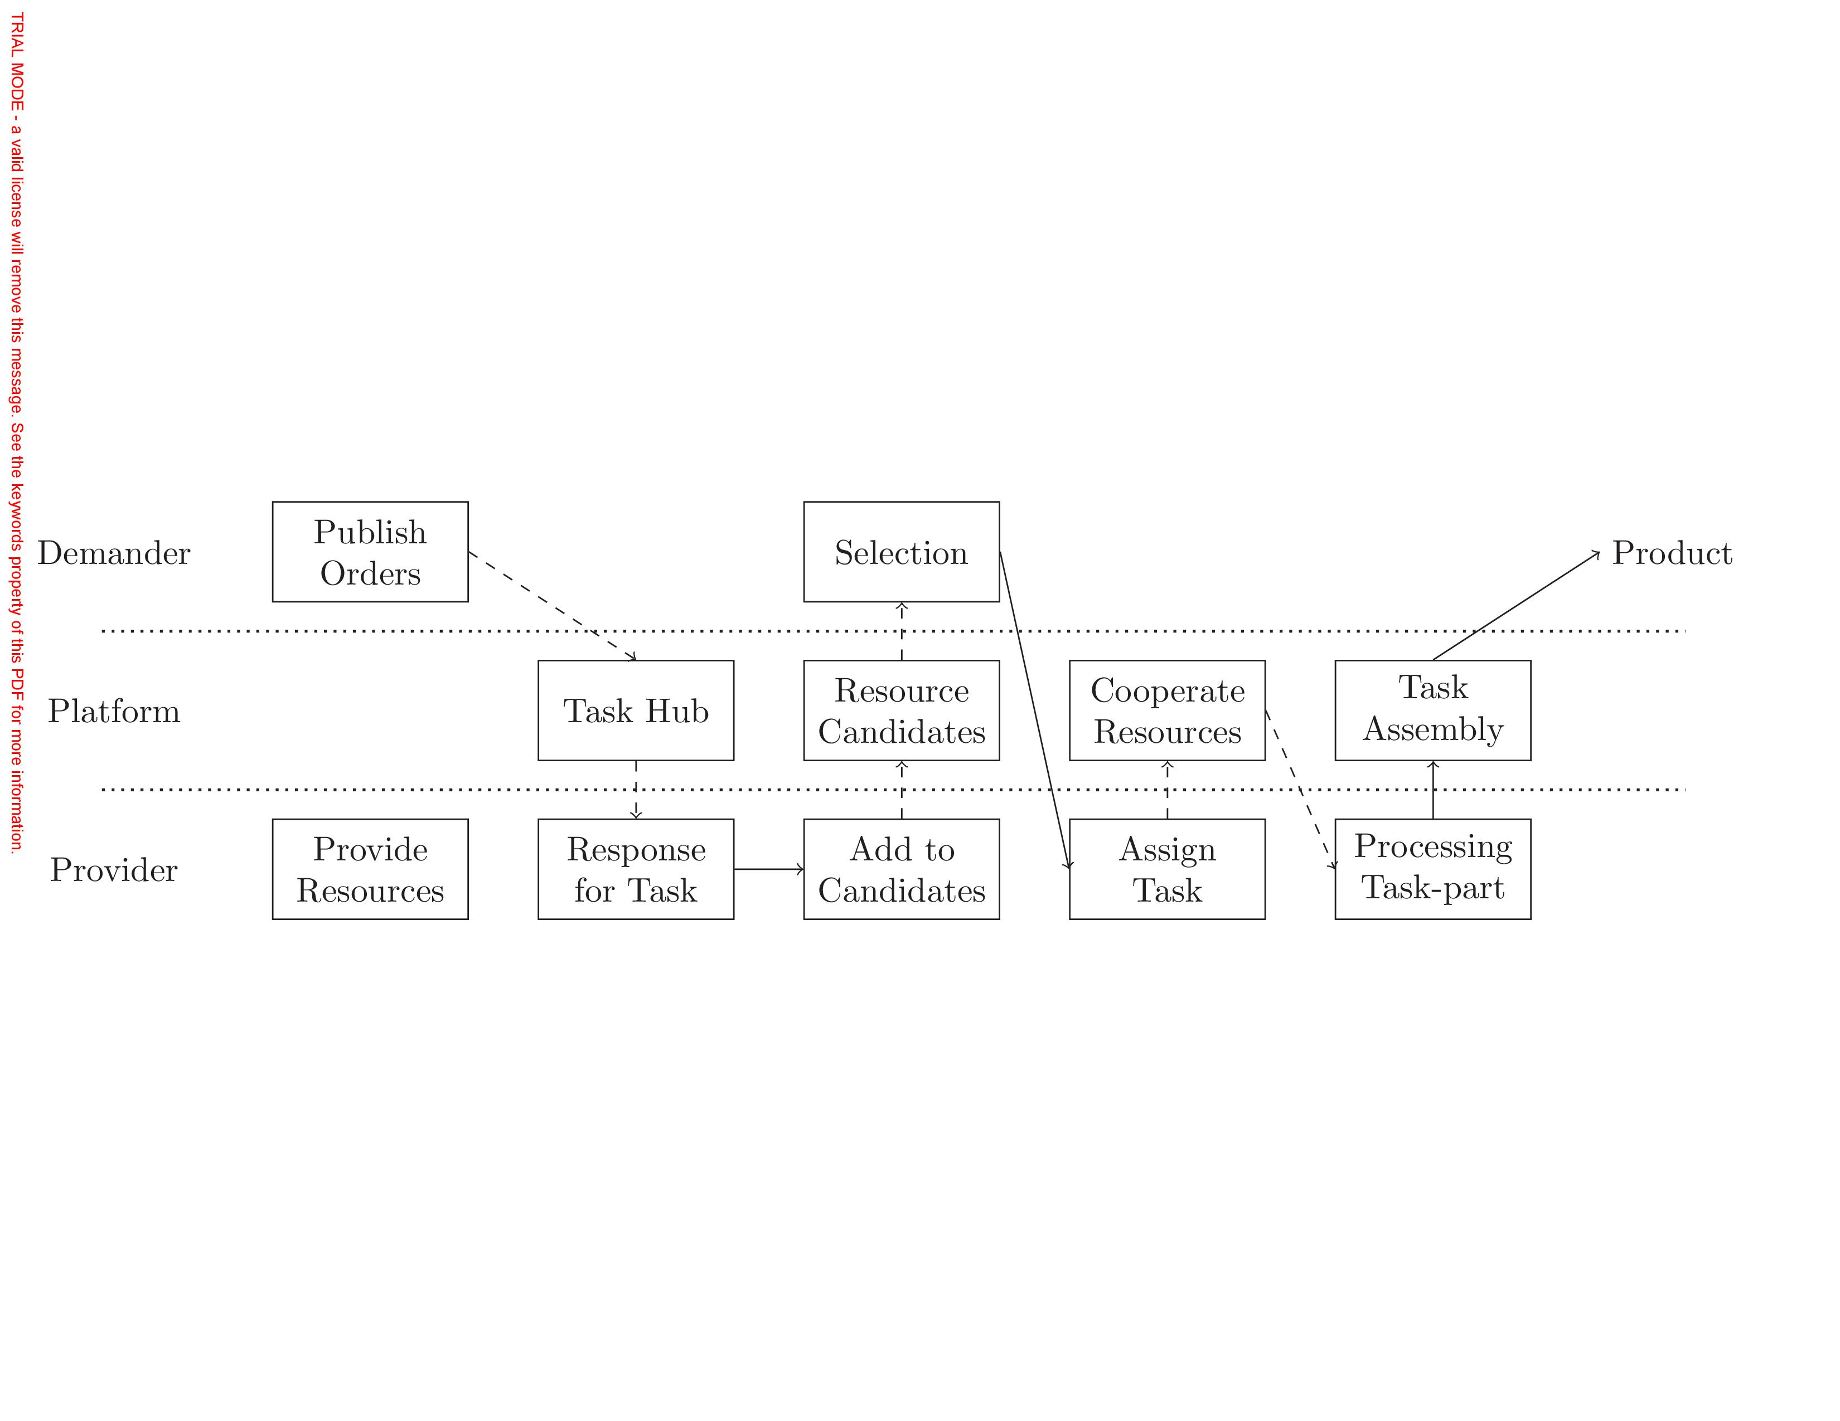

Fig. 1. Original mode

In this mode, individual executes activities that interact with others depicted by object flow (full lines) and information flow (dashed lines). The demander publish order that can be described by an activity-on-node (AON) network where the node represent the task and the arc the precedence relation. Each task needs to be performed with pre-determined configuration of resources. Hence, even after response and assign procedure, the selected resource cannot start to process the task until all of other selected resources are ready, we call this procedure as resource cooperation and what each resource actually process is the task-part, which is a virtual segmentation of one task, it just like if we run one program in cloud computing platform, we actually use some quota of provider A's DB and some quota of provider B's CPU, we can consider these as task-parts. Product, the performance result after the process and assembly procedure, will be delivered to demander, then demander change the rank value of the selected resource owners according to the review of the product. Cooperation procedure is necessary because of resource capacity is limited, but task-parts belonging to one task should be processed simultaneously to make sure the required resource capacities are available. We call the task-part is active when being processed, semi-active when selected resource is cooperating, inactive when this part is just assigned to the job queue.

**Nomenclature**

$T_{i}$ Order that come with demander, who can be inquired by $F(⋅)$

$t_{ij}$ Task belongs to $T_{i},t_{ij}∈T_{i}$

$p_{ij}$ Process duration of $t_{ij}$

$γ_{ij}$ Expect quality of product after the finish of $t_{ij}$

$r_{i}$ Release time of all $t_{ij}∈T_{i}$

$f_{ij}$ Actual finish time of $t_{ij}$

$P_{ij}$ The set of predecessor of $t_{ij}$, determined by order and some assign procedure

$mr_{k}$ Resource that come with provider, who can be inquired by $F(⋅)$

$δ_{k}$ Task-part quality produced via resource $mr_{k}$

$C_{k,τ}$ Capacity of $mr_{k}$ at time $τ$

$A_{k,τ}$ Available capacity of $mr_{k}$ at time $τ$

$L_{k,τ}$ The list of inactive job queue of $mr_{k}$ at time $τ$ with sequence

$H_{k,τ}$ The list of semi-active job of $mr_{k}$ at time $τ$

$G_{k,τ}$ The set of active job of $mr_{k}$ at time $τ$

$f_{j}^{\left(s\right)}$ Ideal finish time of $t_{j}$ in $L_{k,τ_{0}}^{\left(s\right)}$ for schedule at $τ_{0}$

$re_{j}$ Remaining process time of $t_{j}$ in $G_{k,τ_{0}}$ for schedule at $τ_{0}$

$A_{ij}$ Resource type subset required by $t_{ij}$

$q_{α,ij}$ Required amount of resource with type $α$ by $t_{ij}$, $α∈A_{ij}$

$sc_{l}$ Service-call generated by provider

$p_{l}$ Process duration of $sc_{l}$

$r_{l}$ Release time of $sc_{l}$

$P_{l}$ The set of predecessor of $sc_{l}$

$A_{l}$ Resource type subset required by $sc_{l}$ or provided by $ms_{l}$

$ms_{l}$ Service that generated after the finish of $sc_{l}$

$Δ_{l}$ Product quality produced via service $ms_{l}$

$mr_{l}$ Resource member set of $ms_{l}$

$q_{l}$ Resource member’s capacity contribution set of $ms_{l}$

$q_{α,l}$ Need resource capacity of $ms_{l}$ with type $α,α∈A_{l}$

$α_{l}$ Subset of $q_{l}$ that consists of all the capacities of type $α$ resources in $mr_{l}$

$L_{l,τ}$ The list of job queue of $ms_{l}$ at $τ$ with sequence

$G_{l,τ}$ The set of active job of $ms_{l}$ at $τ$

$R_{ij,τ}$ Resource candidates set for $t_{ij}$ to select

$B_{ij,τ}$ Resource candidate types set for $t_{ij}$

$S_{ij,τ}$ Service candidates set for $t_{ij}$ to select

$R_{l,τ}$ Resource candidates set for $sc_{l}$ to select

$B_{l,τ}$ Resource candidate types set for $sc_{l}$

$R(⋅)$ Rank inquire function about provider

$F(⋅)$ Owner inquire function about resource or service

$P(⋅)$ Type inquire function about resource type

$x$ Bold font of the variable ($x$) means the temp set of a bunch of these variables

Since demander and provider continuous arrives, there is no upper bound of the subscripts ($i, j,k,l,α$). When in schedule procedure, we omit subscript $i$ for some reasons in Sec. 3.4.

* + 1. Assumptions

To scope our research, we make some assumptions as follows for the original mode, while in other extension, some of the assumptions will be modified.

* Each single task should be assembled by its task-parts, and these parts should be processed simultaneously;
* The quality of product is determined by the worst quality of the selected resource;
* Resource are renewable that the available capacity will be return to when the process procedure finished;
* Resource quality comply normal distribution with given mean and standard deviation by provider when registered;
* Cooperate and process procedure cannot be interrupted;
* Provider can only schedule task-parts in inactive status;
  + 1. Master plan for original mode

A single order consists of a set $T_{i} = \left\{t_{i1} ,t_{i2} ,...\right\}$ of tasks, the tasks are interrelated by kinds of constraints. First, precedence constraints force task $t_{ij}$ not to be started before all its immediate predecessors $P_{ij}$. Second, performing the tasks requires resources with limited capacities. Third, resources cooperation requires all the task-parts in active status. A single resource ($mr_{k}$) belongs to only one type. While being processed, task $t_{ij}$ requires $q_{α,,ij}$ units capacity of the resources with each type $α∈A_{ij}$ during every period of its non-preemptable duration $p_{ij}$. Each resource $mr_{k}$ has a limited capacity $C_{k,τ}$ and available capacity $A_{k,τ}$ at any point in time $τ$. This plan is much like the settings in RCPSP[13] except that the task here need multiple types of resource simultaneously.

* 1. Individual decisions in original mode

Provider makes decision at time $τ≥r_{i}$ to response task if the belonging resource $mr_{k}$ was type matched with $t_{ij}$ ($P\left(mr_{k}\right)∈A_{ij}$). If $A_{k,τ}≥q_{α,,ij}$, provider will response the task need, demander of $t_{ij}$ will add $mr_{k}$ to $R_{ij,τ}$ and $P\left(mr_{k}\right)$ to $B_{ij,τ}$. If $mr_{k}$ was finally selected, available capacity of $mr_{k}$ will change as $A_{k,τ}:=A_{k,τ}-q_{α,,ij}$, the available capacity will be returned back to after the finish of part.

* + 1. Provider response for type matched task
    2. Demander select from resource candidates

Demander make decision about resource selection from $R_{ij,τ}$ when $B_{ij,τ}=A_{ij}$. Without loss of generality, we suppose at time $≥r_{i}$, the decision making of demander can be described as follows:

 (1)

  (2)

  (3)

 (4)

*s.t.*

 (5)

  (6)

The multi-objective in Eq. 1 aims at high quality, high resource owner rank and low waiting queue length. Eq. 2 makes sure that resource capacity is capable to process the task part, Eq. 3–4 restrict the resource candidates’ type in the task configuration, Eq. 5–6 describe decision variable, the demander should make decision to select resource in each type.

* + 1. Provider assign task-part in selected resource

If $mr_{k}$ was selected by the demander of $t_{ij}$, then the provider will add $t_{ij}$ part to $H_{k,τ}$ if $\left|L_{k,τ}\right|=0$, $A_{k,τ}≥q_{α,,ij}$, or to $L_{k,τ}$ otherwise. If all the part of $t_{ij}$ are in semi-active status, then these providers will change all the task-part status from semi-active to active and add to .

* 1. Incubation mode

Incubation mode is one extension on the original mode, the purpose of this mode is to remove the cooperate and assembly procedure in advance by gathering types of resources with certain quota into manufacturing service, which will be incubated as shown in Fig. 2. After the finish of task-part, provider record the resource configuration as task frequency, when the frequency value reached some point, provider will decide to incubate such task-specified service for the future performance.

The first thing of incubation is to publish a job named service-call, which is similar with task except for the capacity dominance feature , which means capacity of selected resource will not be returned back to after the performance of service-call. The process result of one service-call is manufacturing service, which is actually a set of resources that may come from selected providers in the system, it’s possible for more than one resource with same type to make contribution to the formation of one service. No more cooperate and assembly procedure are part of pros of service and product quality will no more restricted to the worst quality of resources for the complementary effect, while the cons of service include that service can only perform specified task. Now we can mark task and service-call as job, resource and service as machine.

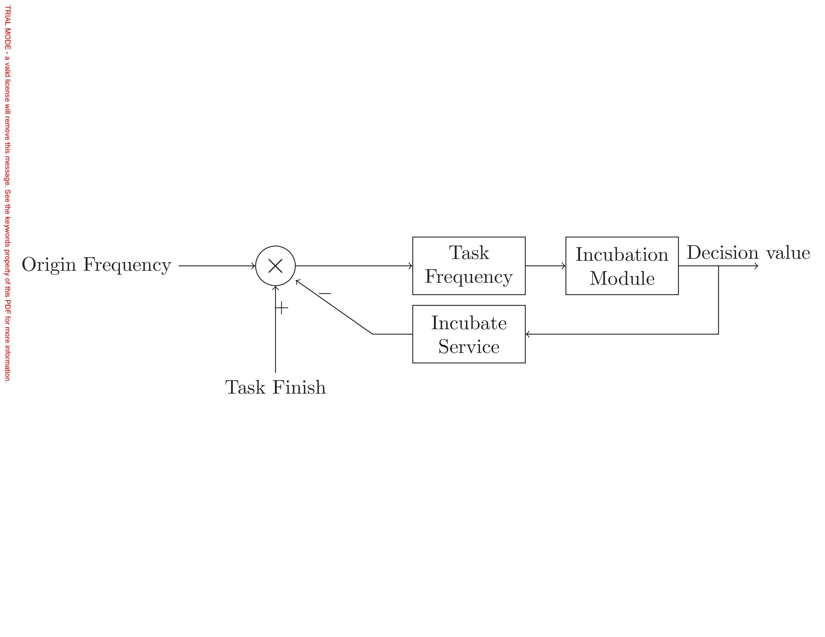

Fig. 2. Incubation mode

* + 1. Provider response for type matched job

Apart from $mr_{k}$ response for $t_{ij}$ as we explained in Sec. 3.2.1, there are 2 other cases in incubation mode:

1. response for $sc_{l}$

If $mr_{k}$ was type matched with $sc_{l}$ ($P\left(mr_{k}\right)∈A_{l}$), as long as $C_{k,τ}>0$, provider of $mr_{k}$ will response the service-call. If $mr_{k}$ was finally selected, both available capacity and capacity will change as Eq. 7a–7b, and these capacity will not be returned back even after the finish of $sc_{l}$ part. Provider of $sc_{l}$ will add $mr_{k}$ to and to .

2. response for $t_{ij}$

Service is task-oriented machine, so if type matched ($A_{ij}=A_{l}$, $\sum_{q∈α_{l}}{q=q_{α,ij}}$), provider of it will response $t_{ij}$ as soon as possible, demander will add to .

* + 1. Demander select from machine candidates

Apart from demander of $t_{ij}$ select $mr_{k}$ as we explained in Sec. 3.2.2 that $B_{ij,τ}=A_{ij}$, $S_{ij,τ}=0$, there are 3 other cases in incubation mode:

1. Select $mr_{k}$ for $sc_{l}$ when $B_{ij,τ}=A_{l}$

Provider of $sc_{l}$ select resource from $R_{l,τ}$ is similar to Eq. 1–6, but the difference is that the $l_{α}$ here is also a set of selected resources with type $α$, $l_{α}$ is subset of decision variable $l$. Selected resources capacity will change as Eq. 7a–7b, and if the sum of capacity quantity in l α less than the sc l required, this selection will not to be executed.

 If  (7a)

 otherwise (7b)

2. Select $ms_{l}$ for $t_{ij}$ when $B_{ij,τ}⊂A_{l},\left|S_{ij,τ}\right|>0$

This situation implies that the resource candidates are not enough and there exists service candidates.

 (8)

 (9)

 (10)

*s.t.*

 (11)

 (12)

Similar to Eq. 1, Eq. 8 is also a multi-objective function that aims at high quality, high service owner rank and low job queue length. Eq. 9–11 explain the service quality distribution parameters, Eq. 12 is the decision variable to select one service in .

3. Select machine for $t_{ij}$ when $B_{ij,τ}=A_{l},\left|S_{ij,τ}\right|>0$

In this situation, demander of $t_{ij}$ will select ether a bunch of resources with cooperation or one single service, so the key idea here is to pre-select optimal resources and optimal service, then to compare these two optimal options to select the better one.

 (13)

 (14)

 (15)

 (16)

 (17)

 (18)

 (19)

*s.t.*

 (20)

 (21)

 (22)

 (23)

 (24)

 (25)

Similar to other situations, Eq. 13 is a multi-objective function that aims at high quality, high rank and low waiting queue length. Eq. 14 and Eq. 22 are the optimal decision in independent conditions, Eq. 15, Eq. 16 and Eq. 17 are the virtual rank value, virtual queue length and virtual quality value that are set in the worst cases. Eq. 17–21 are the virtual quality value calculate procedure. Eq. 25 is the decision to choose one of these two partial optimal decision.

* + 1. Provider assign task to selected machine

Apart from $mr_{k}$ assign $t_{ij}$ when selected as we explained in Sec. 3.2.3, there are 2 other cases in incubation mode:

1. Assign $sc_{l}$ to $mr_{k}$

If $mr_{k}$ is selected by provider of $sc_{l}$ at time $τ$, the assign condition is more restrict than that in Sec. 3.2.3, it should be changed into $\left|L_{k,τ}\right|=\left|G_{k,τ}\right|=\left|H_{k,τ}\right|=0$, for the capacity dominance feature of service-call, we need to assign this type of job one by one. Then, the provider of $mr_{k}$ should change the predecessor set:

 (26)

and all the task assign after $τ$, we say $τ’ > τ$ will set:

 (27)

And $A_{k,τ}$ will be changed with the same amount in Eq. 7a–7b.

2. Assign $t_{ij}$ to $ms_{l}$

Assign $t_{ij}$ to $ms_{l}$ is very simple and there will be no semi-active status for $t_{ij}$, hence it will add to $G_{k,τ}$ if $\left|G_{k,τ}\right|=0$, or to $L_{k,τ}$ otherwise.

* 1. Provider schedule the jobs in machine

In order to reduce the idle rate, provider will schedule the inactive jobs on their machines. Since the schedule in service is a single machine scheduling problem that not on what we focus in this study, we only discuss the job scheduling in resource. Since the resource capacity dominance feature of service-call, it’s necessary to suspend service-call in inactive status until all the job before it in $L_{k,τ}$ are finished, at the meantime, all the job after service-call should be stay in inactive status until the service-call is finished, as shown in Fig. 3, service-call likes partition plate in $L_{k,τ}$. Therefore, we just need to schedule the tasks before the first service-call in $L_{k,τ}$ when one of the active job in $G_{k,τ}$ was finished at $τ_{0}$, we denote the set of schedule task at this time as $L_{k,τ_{0}}^{\left(s\right)}$.



Fig. 3. Simple illustration for one $L_{k,τ}$

Specifically, a simple instance with configuration Tab. 1 and schedule chart Fig. 4 will elucidate the setting.

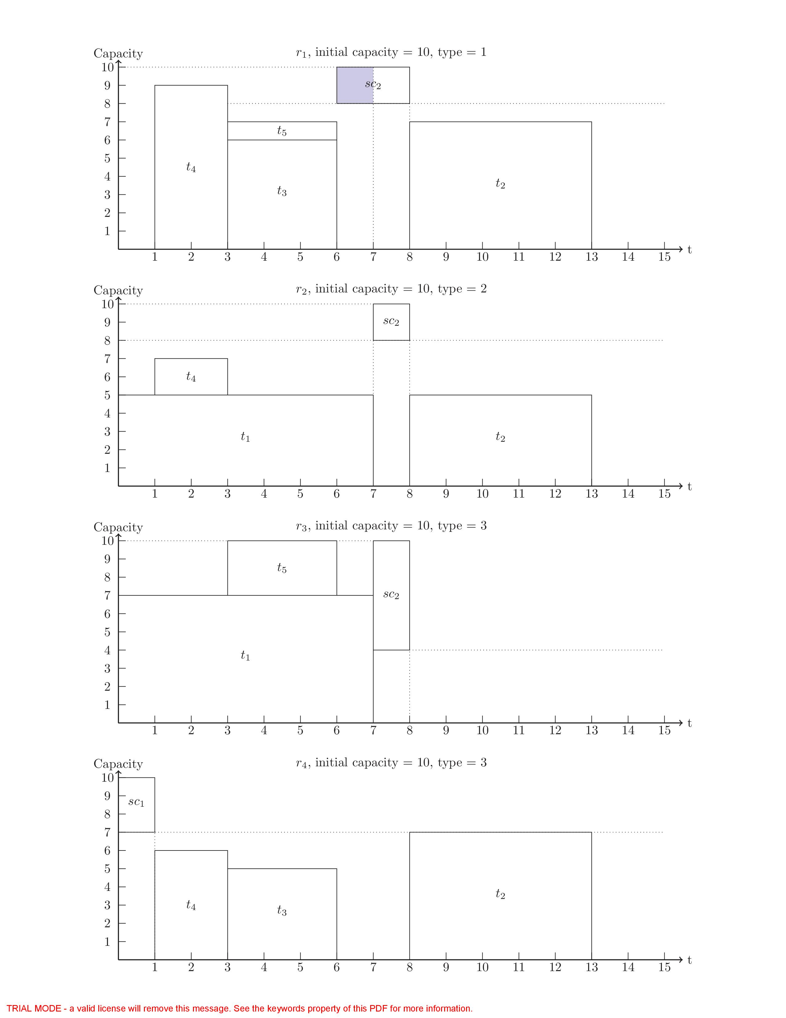

Fig. 4. Simple instance schedule chart with 4 resources in 3 different types

This instance makes some simplification in the subscript fields in order to emphasize the resource cooperation, all the job performance can only be started when all its parts are in semi-activate status, the shadow in the figure shows the waiting period between the status transitions. Horizontal dotted line constrained the available capacity of the resource for the subsequent jobs. Each finish of service-call will make the horizontal dotted line lower and it will never get higher again unless the related service is repealed.

Table 1. Simple job configuration

|  |  |  |  |  |  |
| --- | --- | --- | --- | --- | --- |
| Job | Need Resource Capacity | | | Release Time | Process Duration |
| Type 1 | Type 2 | Type 3 |
| $$t_{1}$$ | 0 | 5 | 7 | 0 | 7 |
| $$t_{2}$$ | 7 | 5 | 7 | 4 | 5 |
| $$t_{3}$$ | 6 | 0 | 5 | 2 | 3 |
| $$t_{4}$$ | 9 | 4 | 6 | 1 | 2 |
| $$t_{5}$$ | 1 | 0 | 3 | 2 | 3 |
| $$sc_{1}$$ | 0 | 0 | 3 | 1 | 1 |
| $$sc_{2}$$ | 2 | 7 | 6 | 3 | 1 |

In every single resource, a schedule is given by a vector of ideal finish times $f^{\left(s\right)}=[f_{1}^{\left(s\right)},f_{2}^{\left(s\right)},...,f_{n}^{\left(s\right)}]$, $n=\left|L_{k,τ_{0}}^{\left(s\right)}∪H_{k,τ_{0}}^{\left(s\right)}\right|$. Since the task in $L_{k,τ_{0}}^{\left(s\right)}$, $H_{k,τ_{0}}^{\left(s\right)}$ and $G_{k,τ_{0}}$ may come from different orders, we here use the single uniform subscript $j$ to distinguish these tasks and their related variables, we ignore the type subscript $α$ because all the job assigned here are already type matched. The schedule model is:

 (28)

 (29)

  (30)

 (31)

*s.t.*

  (32)

  (33)

  (34)

The schedule aim for each resource Eq. 28 is to minimum the maximum delay of jobs. Eq.30 makes sure that all predecessors of each job finished before the job itself. Eq. 32 means that the finish time of activate job is determined. Eq. 33 makes sure the capacity restriction at every time period and Eq. 34 defines the extreme situation of the finish time. Since Eq. 33 is a time dependent function, the schedule model cannot be solved with mixed integer programming (MIP) techniques.

* 1. Outsourcing mode

Outsourcing mode is one extension on the original mode and will be active when incubation mode is on that only service can perform this procedure. As shown in Fig. 5, the idea of outsourcing for service is to republish active or inactive task to platform again in order to reduce its job queue length to enhance the probability to be selected by new tasks. For each single task $t_{j}∈L_{l,τ}∪G_{l,τ}$, the only condition to make the outsource decision is that if the maximum delay ($f_{j}-p_{j}-r_{j}$) of task in both status decreases. This decision highly depends on the estimation of other resources and services’ performance status. Outsourcing mode makes it possible to paralleled process one job.

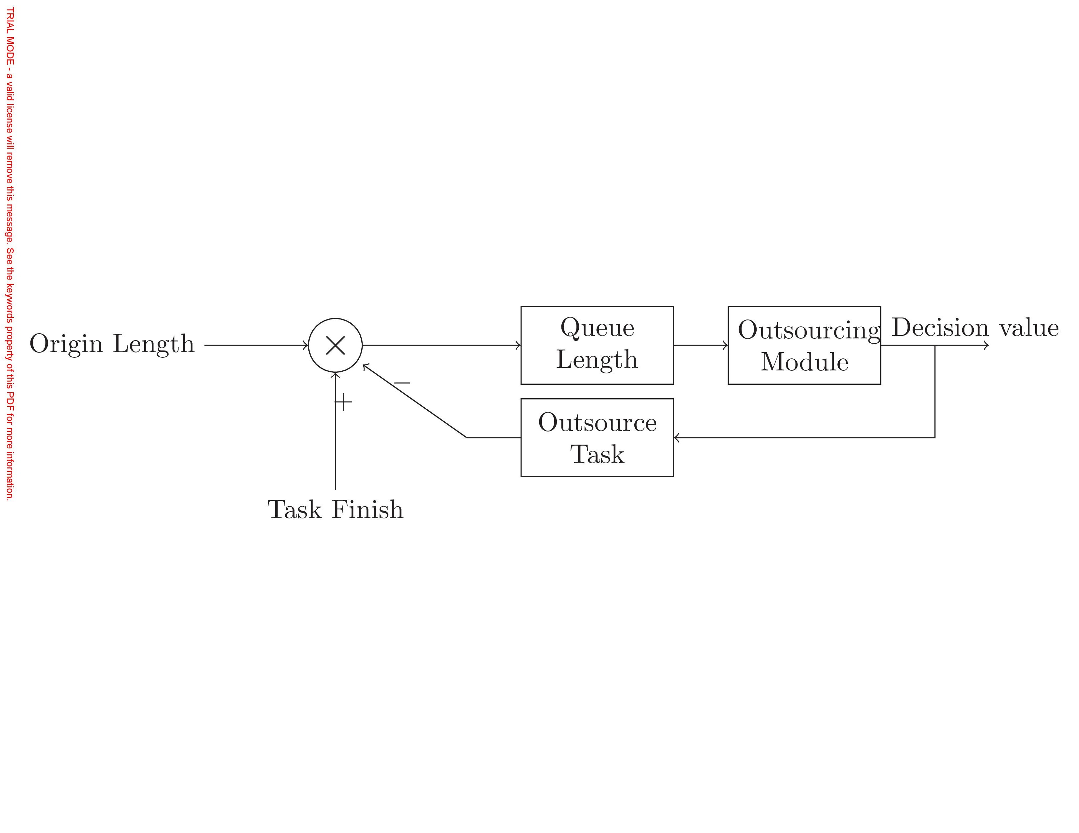

Fig. 5. Outsourcing mode

* 1. Metabolism mode

Metabolism mode is one extension on the original mode for platform operator to control the number of individual in the system by both restrict the arrival and eliminate the current members. As shown in Fig. 6, we can define machine scarcity as $\sum_{j}{q_{α,ij}}-\sum_{k}{C_{k,τ}}$.

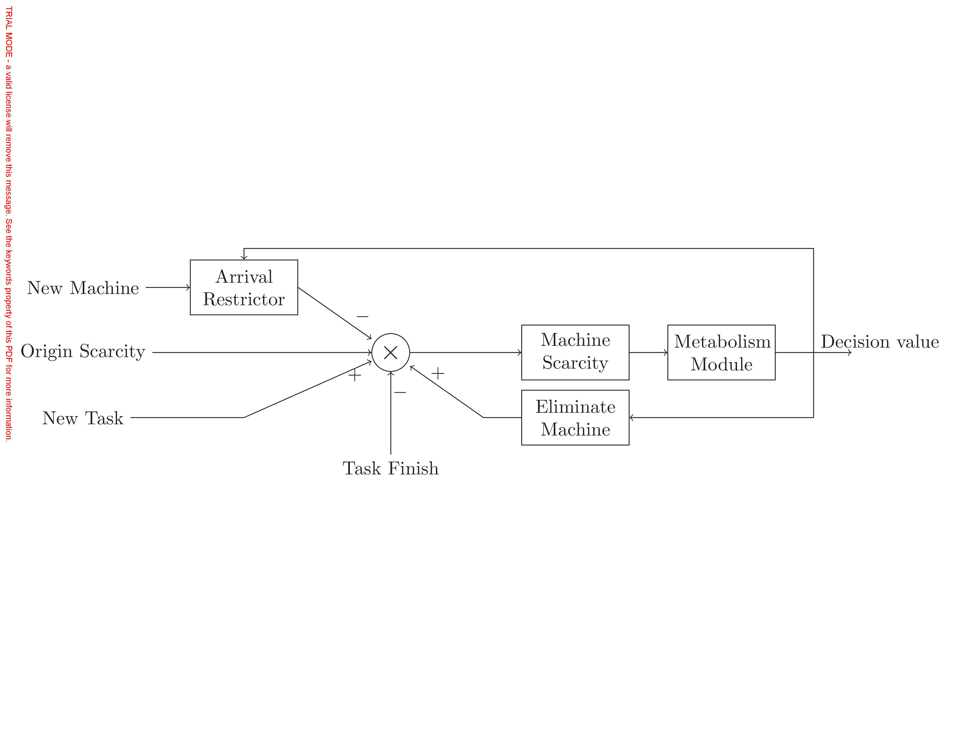

Fig. 6. Metabolism mode

Platform restrict the arrival of new machine by block the registration, eliminate the current machine by their quality and owner’s rank. Rank value is initialized to 0 and will be changed by demander’s review after the finish of task:

  (35a)

 (35b)

  (35c)

The change of rank value can be determined by:

 (36)

1. Experiment and result Analysis

Individuals in the manufacturing ecosystem are: 1) autonomous and self-directed, 2) social, interacting with other entities, 3) controlled by the environment, 4) self-contained. They optimize their multi-objective decision makings to interact with others and the environment, hence, agent-based modeling and simulation (ABMS) technique[14,15] is suitable for the study in such complex system. With the help of Repast Simphony[16] package, we realized the ecosystem model and performed some experiments with it.

* 1. Experiments

We use the RanGen[17] to generate order dataset in the well-known Patterson format with the parameters setting listed in Tab. 2. First 5 parameters are defined in [17], $λ$ is the parameters of the arrival of user in simulation, $C_{k,0}$ is the initial capacity for $mr_{k}$.

We assume provider and demander are arriving as the Poisson process, in order to make sure the coming need resource capacity rate will not exceed the coming resource capacity rate in average to prevent the task explosion, and we make sure that:

 (37)

Table 2. Order generating parameters setting

|  |  |  |  |  |  |  |  |  |
| --- | --- | --- | --- | --- | --- | --- | --- | --- |
| $$n_{α}$$ | OS | CI | $$n_{r}$$ | RF | RC | $$λ_{d}$$ | $$λ_{p}$$ | $$C_{k,0}$$ |
| 10 | 0.3 | [2,3] | 12 | 0.3 | 0.5 | 0.2 | 0.3 | [20,30] |

We design experiments in groups to validate incubation, outsourcing and metabolism mode Tab. 3, 10 datasets represent 10 types of orders, and each of them contains 10 tasks with different configuration on 12 types of resources to perform with.

Table 3. Experiments mode grouping

|  |  |  |  |
| --- | --- | --- | --- |
|  |  | No metabolism | Metabolism |
| Resource-only |  | Mode 11 | Mode 12 |
| Incubation | No outsourcing | Mode 21 | Mode 22 |
| Outsourcing | Mode 31 | Mode 32 |

* 1. Result and analysis

Experiment on each mode in one group are simulated with same random seed to make no difference on the coming of order, provider and other irrelevant configuration to our validation. After bunch of experiments with different random seeds, take random seed 776189616 as example, we run the simulation for 6000 tick time and the experiment’s results are displayed in Fig. 7 and Tab. 4, we find: 1) Most dotted lines are above the full lines with the same series in $N_{R} ,N_{P} ,N_{T}$ means that metabolism mode need lower number of provider and resource, with the price of higher number of queue length of the tasks in resources in the system to deal with the same amount of needs, except for Mode 22. Full lines are not much above dotted lines in $N_{F}$ means that task finish rate will be a little lower with the metabolism, exception also appears in Mode 22.

2) and both represent the job queue length, triangle and square line turned lower in $L$ means that incubation mode can help reduce the waiting of job, these two type of line above the circle line means the incubation mode do reduce the resource idle rate.

3) Triangle lines are a little above the square lines in $N_{R} ,N_{P} ,N_{T}$ means that outsourcing mode needs more resources to operate and can only reduce the job queue length a little.

4) There is no big difference among all the 6 modes in rank change. Provider in metabolism mode will get lower rank value for they cannot stay in the system for a longer time to get higher rank value. Provider in Mode 11 even will not promote their rank value, which means that the metabolism rate is very fast if without incubation mode.

5) Mode 22 is a very special mode that reached the balance within 6000 ticks, that the number of provider and resource changes little with time goes by. Because our experiment setting comply Eq. 37, the coming need capacity rate is lower than the coming capacity rate, Mode 12,22,32 will finally reach balance in the long run theoretically, but the appearance of service-call and metabolism mode itself is full of uncertainty, thus it’s hard to predict when other metabolism related mode will reach the balance

Table 4. Average observed values

|  |  |  |  |  |  |
| --- | --- | --- | --- | --- | --- |
| Mode | $$\overline{N_{T}}$$ | $$\overline{N_{F}}$$ | $$\overline{N_{P}}$$ | $$\overline{N_{R}}$$ | $$\overline{Q}$$ |
| Mode 11 | 1159.36 | 1644.201 | 1177.601 | 2053.727 | 8.388 |
| Mode 21 | *636.769* | *2031.215* | **692.716** | **1066.947** | 16.016 |
| Mode 31 | 779.413 | 1996.021 | *782.272* | *1203.748* | 15.174 |
| Mode 12 | 1439.831 | 1522.923 | 1797.883 | 2954.113 | 14.057 |
| Mode 22 | **343.444** | **2464.407** | 1316.952 | 1957.226 | *20.251* |
| Mode 32 | 1164.409 | 1907.011 | 1597.742 | 2428.155 | **20.652** |

6) With the average data value shown in Tab. 4, metabolism with incubation but not with outsourcing mode is one ideal combine mode to maintain the system, resource will self-configured and controlled to justly meet the task need.

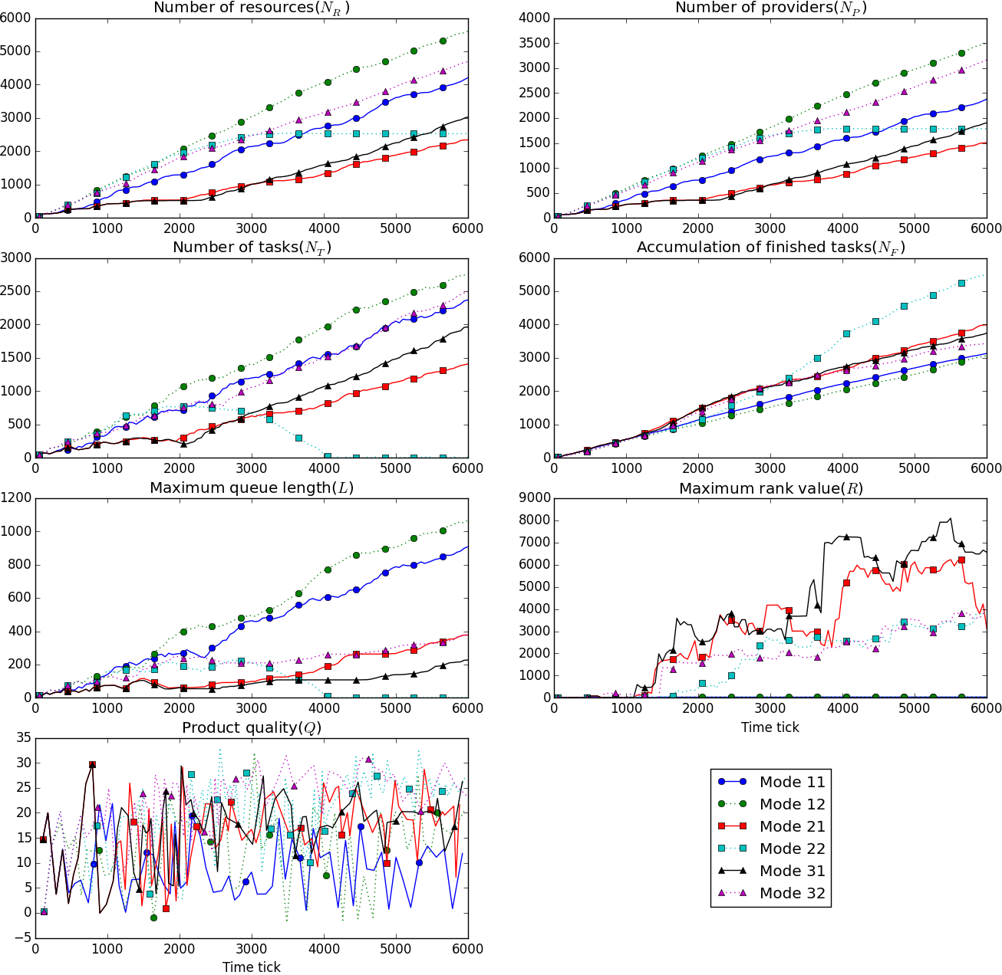

Fig. 7. Observed variable change with time

1. Limitations, and Future Research

We only proposed 3 extensions to combine and it may not fully describe the operation mode of cloud manufacturing system, it may also limit the evolution direction of the ecosystem, hence we will design more extensions. The assignment of service-call is oversimplified to prevent complex consequence, we will design new approaches to assign this job.

Acknowledgements

This work is supported by the National Natural Science Foundation of China (No. 71571161), and the National High Technology Research and Development Program of China (863 Program) (No. 2015AA042101).

References

[1] X. Xu, From cloud computing to cloud manufacturing, Robotics andComputer-Integrated Manufacturing 28 (1) (2012) 75 – 86.

[2] F. Tao, L. Zhang, K. Lu, D. Zhao, Research on manufacturing grid resource service optimal-selection and composition framework, Enterprise Information Systems 6 (2) (2012) 237–264.

[3] O. F. Valilai, M. Houshmand, A collaborative and integrated platform to support distributed manufacturing system using a service-oriented approach based on cloud computing paradigm, Robotics and Computer-Integrated Manufacturing 29 (1) (2013) 110–127.

[4] B. Lv, A multi-view model study for the architecture of cloud manufacturing, in: Digital Manufacturing and Automation (ICDMA), 2012 Third International Conference on, July 31 2012-Aug. 2 2012, pp. 93–97.

[5] B.-H.Li, L.Zhang, S.-L.Wang, F.Tao, J.Cao, X.Jiang, X.Song, X.Chai, Cloud manufacturing: a new service-oriented networked manufacturing model, Computer integrated manufacturing systems 16 (1) (2010) 1–7.

[6] W. Liu, B. Liu, D. Sun, Y. Li, G. Ma, Study on multi-task oriented services composition and optimisation with the 'Multi-Composition for Each Task' pattern in cloud manufacturing systems, International Journal of Computer Integrated Manufacturing 26 (8) (2013)

[7] S. C. Oh, D. Lee, S. R. T. Kumara, Effective web service composition in diverse and large-scale service networks, IEEE Transactions on Services Computing 1 (1) (Jan.-March 2008) 15–32.

[8] J. S. Smith, Survey on the use of simulation for manufacturing system design and operation, Journal of Manufacturing Systems 22 (2) (2003) 157 – 171.

[9] I. Sabuncuoglu, O. B. Kizilisik, Reactive scheduling in a dynamic and stochastic fms environment, International Journal of Production Research 41 (17) (2003) 4211–4231.

[10] T. Felberbauer, K. Altendorfer, A. HÃijbl, Using a scalable simulation model to evaluate the performance of production system segmentation in a combined mrp and kanban system, in: Proceedings of the 2012 Winter Simulation Conference (WSC), 9-12 Dec. 2012, pp. 1–12.

[11] D. Mourtzis, N. Papakostas, D. Mavrikios, S. Makris, K. Alexopoulos, The role of simulation in digital manufacturing: applications and outlook, International Journal of Computer Integrated Manufacturing 28 (1) (2015) 3–24.

[12] D. Wu, M. J. Greer, D. W. Rosen, D. Schaefer, Cloud manufacturing: Strategic vision and state-of-the-art, Journal of Manufacturing Systems 32 (4) (2013) 564–579.

[13] R. Kolisch, S. Hartmann, Heuristic algorithms for the resource constrained project scheduling problem: Classification and computational analysis, in: J. WÄ ´ Zglarz (Ed.), International Series in Operations Research & Management Science, Vol. 14, Springer US, 1999, pp. 147–178.

[14] C.M.Macal, M.J.North, Agent-basedmodelingandsimulation, in: Winter Simulation Conference, Winter Simulation Conference, Austin, Texas, 2009, pp. 86–98.

[15] M. J. North, C. M. Macal, Managing business complexity: discovering strategic solutions with agent-based modeling and simulation, Oxford University Press, 2007.

[16] M. J. North, N. T. Collier, J. Ozik, E. R. Tatara, C. M. Macal, M. Bragen, P. Sydelko, Complex adaptive systems modeling with repast simphony, Complex Adaptive Systems Modeling 1 (1) (2013) 1–26.

[17] E. Demeulemeester, M. Vanhoucke, W. Herroelen, Rangen: A random network generator for activity-on-the-node networks, Journal of Scheduling 6 (1) (2003) 17–38.